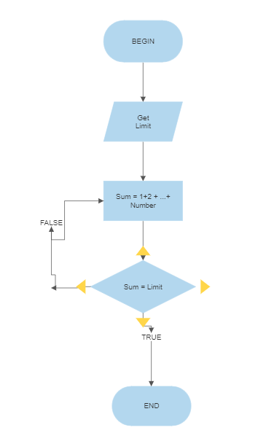  
GET limit  
  
SUM plus 1  
  
IF Sum is equal to 1  
  
 ELSE Sum plus 1   
  
ENDIF